|  |  |  |
| --- | --- | --- |
| SCHOOL OF INFORMATION AND TECHNOLOGY | | |
| NAME: Caccam, Jesus Allyson | DATE PERFORMED: September 12, 2024 |  |
| Section: IDC2 | DATE SUBMITTED: September 12, 2024 |

# SYSADM1 – Managing Services in Linux

# Requirement:

* A virtual machine running Linux

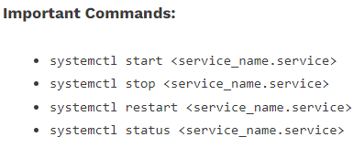

Complete this lab as follows:

Use the service –status-all command to list all active and inactive services.

List down active and inactive services in the table below. Provide five (5) services for each column.

|  |  |
| --- | --- |
| **Active** | **Inactive** |
| Alsa-utils | Anacron |
| Apport | apparmor |
| cron | bluetooth |
| cups | Console-setup.sh |
| dbus | cryptdisks |

SS:

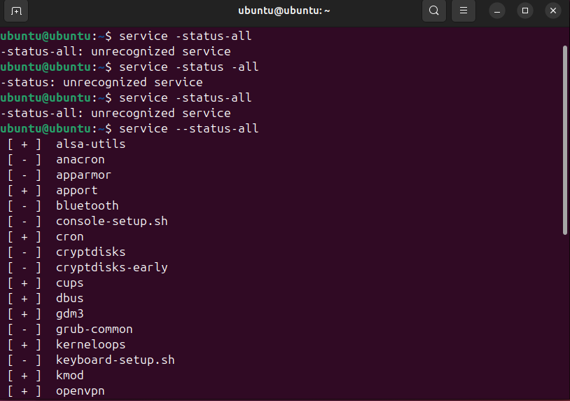

Start the Bluetooth service using the systemctl command.

Ex. sudo systemctl start httpd

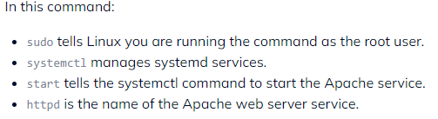

Check the status of the Bluetooth service. What is its status?

SS: 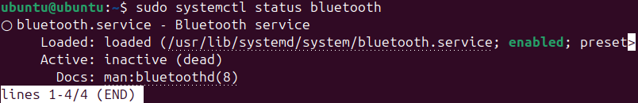

* **The status of the bluetooth is enabled**

Check the status of the cups services. Since when was it running?

SS: 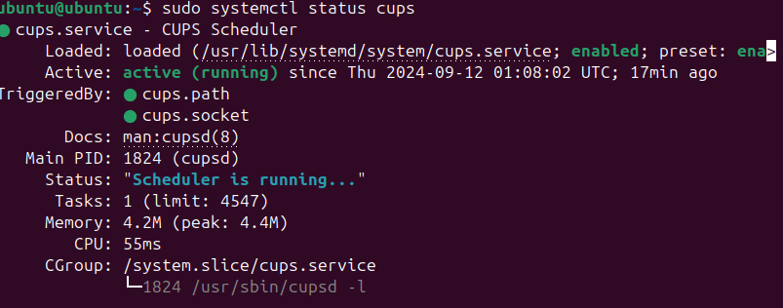

* The cups services started running on this day sept. 12, 2024, and running 17 minutes ago.

Stop cups services.

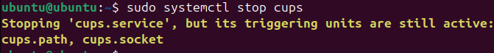

Verify if the service was stopped.

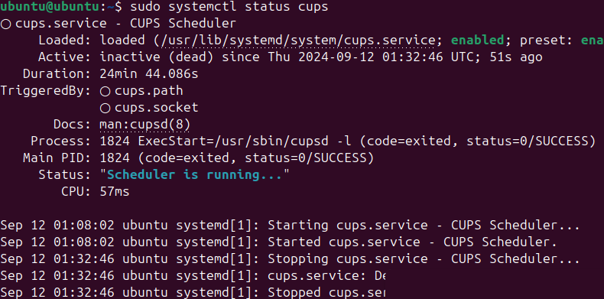

Restart the cups services



Verify if the service was restarted.

